Andrew Tressler

Srilekha Dodda

CS3502

31 October 2025

Project 1 – Phase 2

Priority

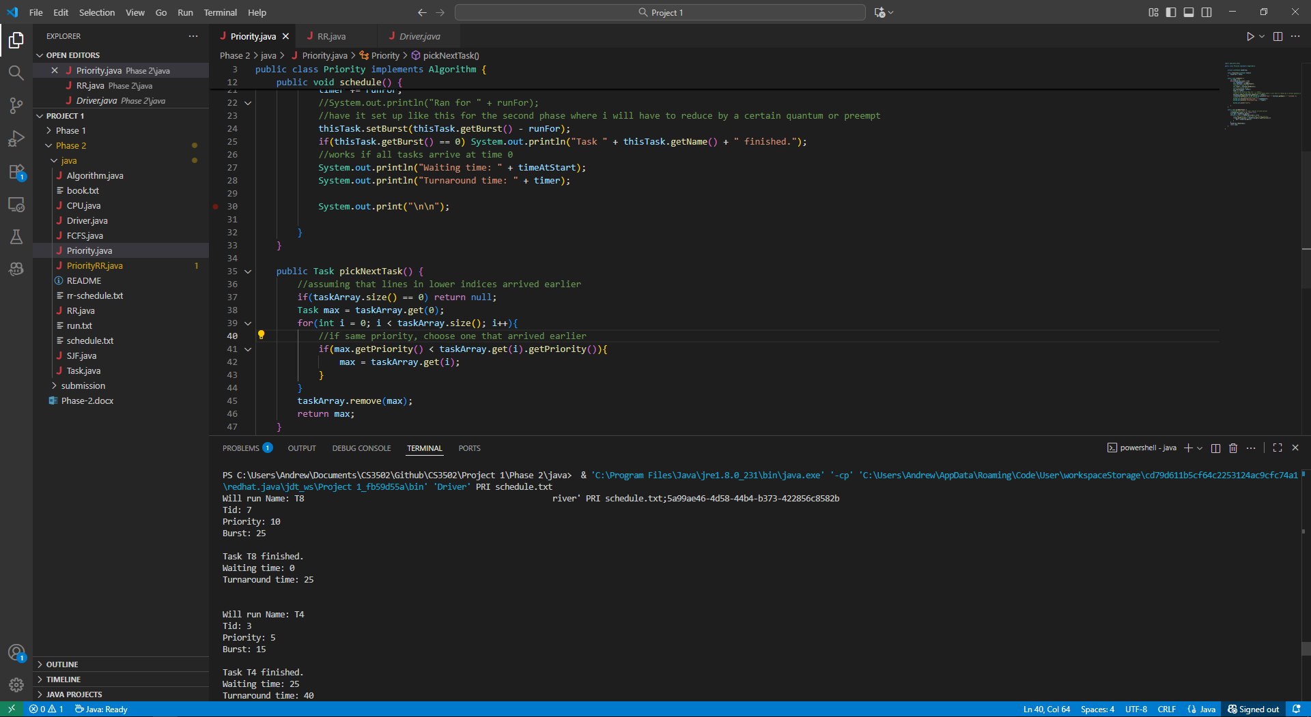

Will run Name: T8

Tid: 7

Priority: 10

Burst: 25

Task T8 finished.

Waiting time: 0

Turnaround time: 25

Will run Name: T4

Tid: 3

Priority: 5

Burst: 15

Task T4 finished.

Waiting time: 25

Turnaround time: 40

Will run Name: T5

Tid: 4

Priority: 5

Burst: 20

Task T5 finished.

Waiting time: 40

Turnaround time: 60

Will run Name: T1

Tid: 0

Priority: 4

Burst: 20

Task T1 finished.

Waiting time: 60

Turnaround time: 80

Will run Name: T2

Tid: 1

Priority: 3

Burst: 25

Task T2 finished.

Waiting time: 80

Turnaround time: 105

Will run Name: T3

Tid: 2

Priority: 3

Burst: 25

Task T3 finished.

Waiting time: 105

Turnaround time: 130

Will run Name: T7

Tid: 6

Priority: 3

Burst: 30

Task T7 finished.

Waiting time: 130

Turnaround time: 160

Will run Name: T6

Tid: 5

Priority: 1

Burst: 10

Task T6 finished.

Waiting time: 160

Turnaround time: 170

RR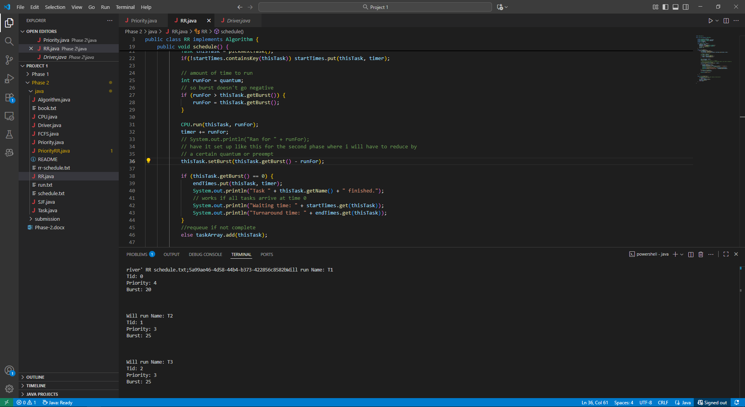

Will run Name: T1

Tid: 0

Priority: 4

Burst: 20

Will run Name: T2

Tid: 1

Priority: 3

Burst: 25

Will run Name: T3

Tid: 2

Priority: 3

Burst: 25

Will run Name: T4

Tid: 3

Priority: 5

Burst: 15

Will run Name: T5

Tid: 4

Priority: 5

Burst: 20

Will run Name: T6

Tid: 5

Priority: 1

Burst: 10

Task T6 finished.

Waiting time: 50

Turnaround time: 60

Will run Name: T7

Tid: 6

Priority: 3

Burst: 30

Will run Name: T8

Tid: 7

Priority: 10

Burst: 25

Will run Name: T1

Tid: 0

Priority: 4

Burst: 10

Task T1 finished.

Waiting time: 0

Turnaround time: 90

Will run Name: T2

Tid: 1

Priority: 3

Burst: 15

Will run Name: T3

Tid: 2

Priority: 3

Burst: 15

Will run Name: T4

Tid: 3

Priority: 5

Burst: 5

Task T4 finished.

Waiting time: 30

Turnaround time: 115

Will run Name: T5

Tid: 4

Priority: 5

Burst: 10

Task T5 finished.

Waiting time: 40

Turnaround time: 125

Will run Name: T7

Tid: 6

Priority: 3

Burst: 20

Will run Name: T8

Tid: 7

Priority: 10

Burst: 15

Will run Name: T2

Tid: 1

Priority: 3

Burst: 5

Task T2 finished.

Waiting time: 10

Turnaround time: 150

Will run Name: T3

Tid: 2

Priority: 3

Burst: 5

Task T3 finished.

Waiting time: 20

Turnaround time: 155

Will run Name: T7

Tid: 6

Priority: 3

Burst: 10

Task T7 finished.

Waiting time: 60

Turnaround time: 165

Will run Name: T8

Tid: 7

Priority: 10

Burst: 5

Task T8 finished.

Waiting time: 70

Turnaround time: 170